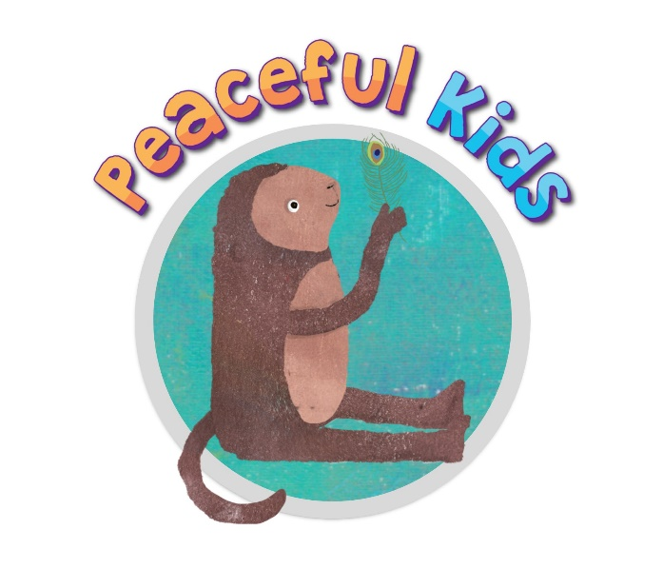
Peaceful Kids program
‘Peaceful Kids’ is a Mindfulness and Positive Psychology based program to lessen anxiety and stress and increase resilience in children. The program gives children the skills, practice and support to utilize coping strategies that lessen the symptoms of anxiety and stress. The program also involves parental involvement and commitment to supporting the strategies at home.

Outcomes of the Peaceful Kids program:  - Lessen symptoms of anxiety and stress in children  - Teaches children to self-calm  - Empowers children to manage th, eir own anxiety  - Develops emotional intelligence skills  - Teaches children life-long skills to manage stress and prevent stress build up  - Supports children so they know that they are not alone with suffering from anxiety | Program structure:  - Peaceful Kids is a 8 week program for children  - Sessions are for approximately 1 hour each week. (40-50 minutes for Prep and Year 1’s)  - Sessions include learning a range of mindfulness strategies and meditations and positive psychology exercises.  - Students are guided through meditations daily online via the Peaceful Kids website: peacefulkids.com.au

More information on the Peaceful Kids program: www.peacefulkidsclasses.com
Next group to be held at your school:
10am Mondays,
Starting on 10th August
Cost: $ … for 8 weeks

Bookings:
Your name, your email, your phone number, your peacefulclasses webpage

