Peaceful Parents Workshop

The Peaceful Parents Workshop is a Mindfulness and Positive Psychology based parenting workshop to increase parent’s wellbeing. Parents learn strategies to lessen stress, enjoy parenting more as well as learning practical strategies to support and build resilience in their children.

Parents discover strategies for themselves...

Mindfulness strategies
Slowing life down & being more in Flow
Enjoying parenting more & reducing stress
Resilience building exercises & strategies
Mindful parenting strategies
Self-Care & Wellbeing Boosters
Positive psychology strategies to boost wellbeing

And to support their children...
Mindful listening & responding
Effective Coping Strategies
Managing children’s feelings & worries
Problem Solving strategies

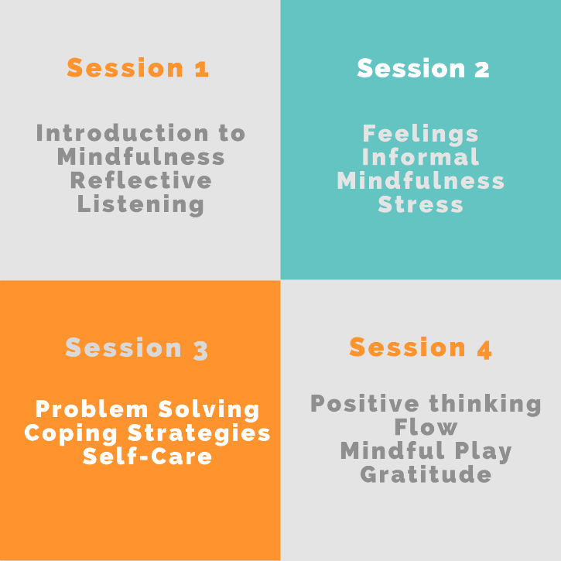

Workshop structure:
- The Peaceful Parents workshop runs over 4 weeks.
- Sessions are for approximately 2 hours each week.
- A commitment to all 4 weeks is essential.

Peaceful Parents - Forward by Andrew Fuller
Forward by Andrew Fuller

“The strongest predictor of life success for children is being able to regulate emotions. This means when they are feeling anxious or avoidant that they can bring themselves back to being resilient. We can teach children these skills. Even better we can show them how to do it.

This is where the ‘Peaceful Parents’ program is so powerful. By focusing on listening, communication and mindful parenting we can demonstrate these skills to our children day in day out. We also know that our relationships thrive when we Connect, Protect and Respect one another (CPR). Peaceful Parents builds this by helping parents:

Connect
- To their strengths as parents
- Identifying strengths of children
- Developing cultures of unconditional positive regards

Protect
- Know how to handle strong emotions
- How to listen well
- Calming mindfulness and emotional regulation

Respect
- Using the 4 C’s – calm, curious, coach and communicate to develop ways to peacefully parent children

Georgina and the team at Wellbeing for Kids should be congratulated for putting together such a useful resource for parents. Bravo!! “

Andrew Fuller
Author, Clinical Psychologist and Family Therapist
Hon. Fellow, Uni of Melbourne
Ambassador of Adolescent Success
Ambassador of ALDAF
Ambassador for Mind Matter

Purpose

The purpose of the Peaceful Parents program is to enhance parent wellbeing which in turn positively impacts on their children’s wellbeing. Not only is there growing evidence that reducing stress levels in parents naturally lessens the stress in the household for other family members, but it is also common sense. Professor Lea Waters from Melbourne University has found in her research that “Mindfulness in parenting significantly reduces children’s stress levels”. Also as Thich Nhat Han states "In a family, if there is one person who practices mindfulness, the entire family will become more mindful." In his many years of teaching mindfulness to families, he believes that mindfulness has a ripple effect in families.

What is the Peaceful Parents program?

- A 4 session Mindfulness, Positive Psychology & Mindful Education program
- A series of workshops where learning is integrated into everyday lives and each week new strategies are taught and built on the previous week’s learning
- An educational program where parents can also support each other through a group environment

What the program isn’t

- A program to address behavioural management or behavioural problems in children
- A counselling or therapy program for children or adults
- A program to address individual issues with children or adults
- A ‘seminar’ where parents are not participants

Outcomes

The many outcomes of the Peaceful Parents program include:
- Decreasing stress in parents and keeping stress levels low
- Increasing parent’s wellbeing
- Beginning and then maintaining a mindfulness practice to build a buffer against stress
- To mindfully tune into and listen to children so emotions can be expressed freely and safely, which in turn helps children cope with life’s difficulties
- Helping parents to ‘slow life down’ and have more mindful moments in their life
- Increased enjoyment of the parenting journey. The less stress parents have, the more enjoyment they will naturally have
- To support one another on the parenting journey and normalise the difficulties many parents have
- Learning helpful strategies to minimise stress and anxiety in children
- Learning helpful strategies to increase resilience in children
- Building on parents’ strategies to help and empower children to problem solve situations rather than take over, over manage or disempower children

