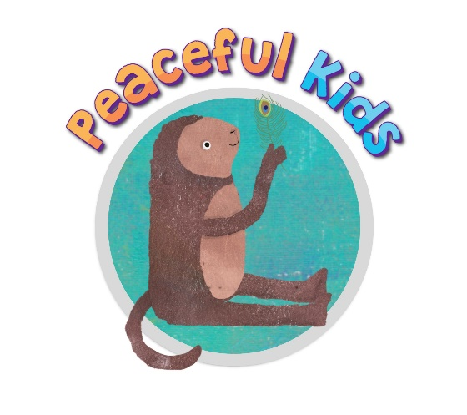

Sample introductory email / letter to schools
(to hold Peaceful Kids within schools)

Hi (Wellbeing leader / Leadership staff name)

My name is (name), and I am a facilitator of Peaceful Kids. The Peaceful Kids program ‘Peaceful Kids’ is a Mindfulness and Positive Psychology based program to lessen anxiety and stress and increase resilience in children. The program has been created to fulfil a need in schools to offer all children a developmentally appropriate program that gives children the skills, practice and support to utilize coping strategies that lessen the symptoms of anxiety and stress. The program also involves parental involvement and commitment to supporting the strategies at home.
As a Peaceful Kids facilitator, I can hold this program within your school during school hours for interested families. I have attached further information that explains the program in more depth including the structure of the program and the benefits.

For more information on the Peaceful Kids program, I would be happy to come to your school to chat with you in person, or to run a free short parent information session, which provides teachers and parents with the opportunity to learn more about the classes and ask any further questions.

If you would like to further discuss this, please don't hesitate to contact me on my mobile (phone number), or email me at (your email)

I look forward to hearing from you.

Kind regards,
(your name)

Sample introductory email / letter to schools
- for classes that will be held outside of schools

Hi (Wellbeing leader / Leadership staff name)

My name is (name), and I am a facilitator of Peaceful Kids. The Peaceful Kids classes run for 8 weeks on (day) for an hour starting from (date) at (venue). From this, I am currently looking for any children that you think may benefit from mindfulness meditations and positive psychology practices who may be struggling with anxiety, stress or poor resilience. The classes also aims at skilling up parents to build resilience in kids, along with providing families, teachers and children with resources that are home and school based activities.

I have attached a flyer for your school newsletter, along with a parent pack to have on hand at the front office if you interested in promoting this to your parents.

For more information on the Peaceful Kids classes, I would be happy to come to your school to run a parents information night that goes for around an hour, which provides teachers and parents with the opportunity to learn more about the classes and ask any further questions.

If you would like to further discuss this, please don't hesitate to contact me on my mobile (phone number), or email me at (your email)

I look forward to hearing from you.

Kind regards,
Your Name

