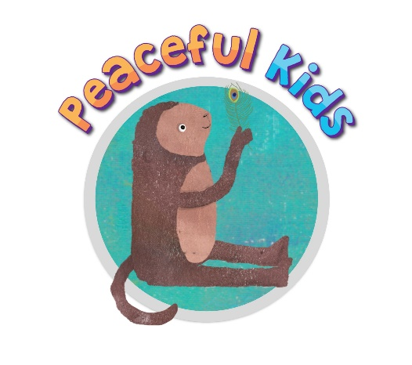

Sample Parent Permission / Consent Form
Add in your own payment details so parents can book directly with you rather than going through the school

DATE

Dear (parent name), thank you for interest in the Peaceful Kids program for your child. Please find attached some information regarding the Peaceful Kids Program.

If you would like your child to be a part of the Peaceful Kids program, please fill in the Permission Form and return it to me via email as soon as possible to secure your child’s place.

I will also be running a parent session at your child’s school on DATE/TIME/PLACE and run for approximately 1 hour. This will be a great opportunity to ask any questions as well as providing you with more information about the program and some essential parenting strategies that help to support anxious children. Please indicate on the attached Permission form if you would like to attend.

Yours Sincerely,

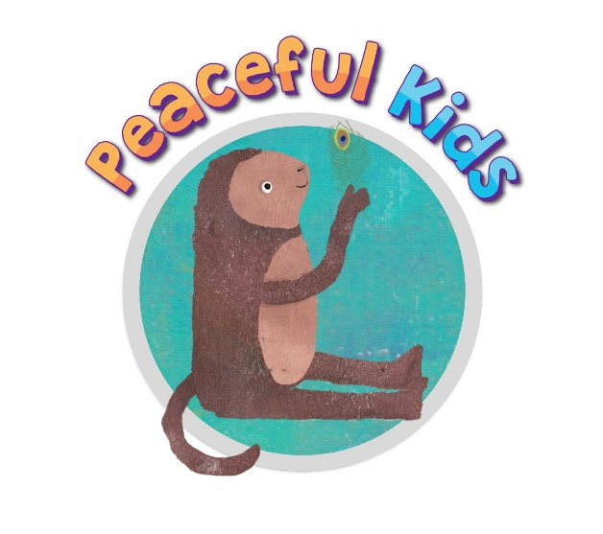
Peaceful Kids program
‘Peaceful Kids’ is a Mindfulness and Positive Psychology based program to lessen anxiety and stress and increase resilience in children. The program gives children the skills, practice and support to utilize coping strategies that lessen the symptoms of anxiety and stress and to build resilience. The program also involves parental involvement and commitment to supporting the strategies at home.

Outcomes of the Peaceful Kids program:
- Lessen symptoms of anxiety and stress in children
- Teaches children to self-calm
- Empowers children to manage their own anxiety
- Develops emotional intelligence skills
- Teaches children life-long skills to manage stress and prevent stress build up
- Supports children so they know that they are not alone with suffering from anxiety

Peaceful Kids is based on evidence-based therapies and research:
- Mindfulness Based Stress Reduction program (MBSR)
- Mindfulness-integrated Cognitive Behaviour Therapy (MiCBT)
- Positive Psychology
- Acceptance and Commitment Therapy

Program structure:
- Peaceful Kids is a 8 week program for children
- Sessions are for approximately 1 hour each week. (40-50 minutes for Prep and Year 1’s)
- Sessions include learning a range of mindfulness strategies and meditations and positive psychology exercises.
- Children are guided through meditations daily online via the Peaceful Kids website: peacefulkids.com.au

Parental involvement:
- A parent session is run for interested parents to explain the program and the pivotal role of mindfulness to lessen and prevent anxiety symptoms.
- Each week the children learn a new mindfulness meditation and positive psychology strategy that they can share with you at home. It would be great to give your child the time to practice these strategies at home, so they learn to incorporate these into their daily lives.

Program Content
Children learn about:
• Basic theory on Mindfulness and how it affects the brain and lessens stress and anxiety
• The different ways to practice Mindfulness and integrate it into their lives
• Their feelings and how this relates to anxiety and stress levels
• Understanding stress and how it relates personally to them
• Understanding triggers for stress and how to calm down when feeling stressed
• Physical symptoms of stress and learning to identify when they need to take time out to calm themselves
• Worrying and how it affects their happiness
• Different types of thinking that increase anxiety or lessen anxiety
• Noticing their own self-talk and how this is affects worrying and stress levels
• Creating a balanced lifestyle including lots of chill out time and being in the flow
Children learn life skills of:
• A range of Mindfulness meditations
• Positive psychology exercises
• Techniques to lessen worrying
• A variety of coping strategies
• A variety of problem solving strategies
• Journaling and expressing their worries
• Facing challenges and fears step by step
• Preventative strategies to help prevent stress build up
• Being attuned to their own bodies and minds
• Being in the flow more regularly and enjoying more of the present moment

What you need to do:
• If you would like your child to participate in the Peaceful Kids program then you will need to sign the permission form and return it to school.
• Come along to the parent session with the time and date on the next page, to find out more about the program and about some essential parenting strategies that help to support anxious children.

Research:
If you would like to learn about Mindfulness and Positive Psychology and its benefits, the following links may be useful to outline the science and evidence-based research that the program is based on.
http://au.reachout.com/what-is-mindfulness
http://www.umassmed.edu/cfm/research/
http://www.mindfulschools.org/about-mindfulness/research
http://www.mindful.org/the-science/medicine/the-science-of-mindfulness
http://www.sciencedaily.com/releases/2011/01/110121144007.htm
http://www.actionforhappiness.org
http://mindfullearning.com.au/about-mindful-learning/authors/
http://www.mindfulness.net.au/what-is-micbt.html

Peaceful Kids Permission Form

I give permission for my child to participate in the Peaceful Kids educational program at VENUE over 8 weeks. I understand the program will be run by (your name) and that my child will be meeting each week for 8 weeks of this term with other students in a similar year level. The first session will be commencing in Week … (week beginning DATE/TIME). I have also read the Parent Information that outlines the content and outcomes of the program.

Please circle if you are available to come along to the parent session on DATE / TIME / PLACE to find out more about the program and about some essential parenting strategies that help to support your child throughout the program.
I would like to attend the Parent Session on DATE / TIME YES / NO

Terms and Conditions
- Full payment is required before the 8-week Peaceful Kids program for your child to attend
- Occasionally children are not suitable for this group workshop which can be due to several reasons including the group dynamics. If your child is struggling to manage the group environment with other children, you will be contacted to discuss alternative options for your child. Alternative options for children can include offering individual sessions or being included in another group at another time. If your child is not being respectful to other children or very disruptive, all efforts will be made to keep your child in the group, however at times children may be asked to leave the group and this will be discussed with you to manage the best way forward.
- At times pre and post surveys are completed with the students to gain insight into the effectiveness of the program and feedback for the facilitator. Names of the students are never used on surveys or kept on file and there is no identifying data to match the children’s answers with their name. Data without the children’s names can be given to the creator of the Peaceful Kids program from time to time, for program evaluation only.

I agree with the above Terms & Conditions I don’t agree with the above Terms & Conditions

Child’s Name: Parent’s Name:

Parent Signature: Date:

