Peaceful Classrooms ‘Chill Out’ Sessions &
‘Peaceful Kids’ Program Proposal
(The School / Organisation Name here)
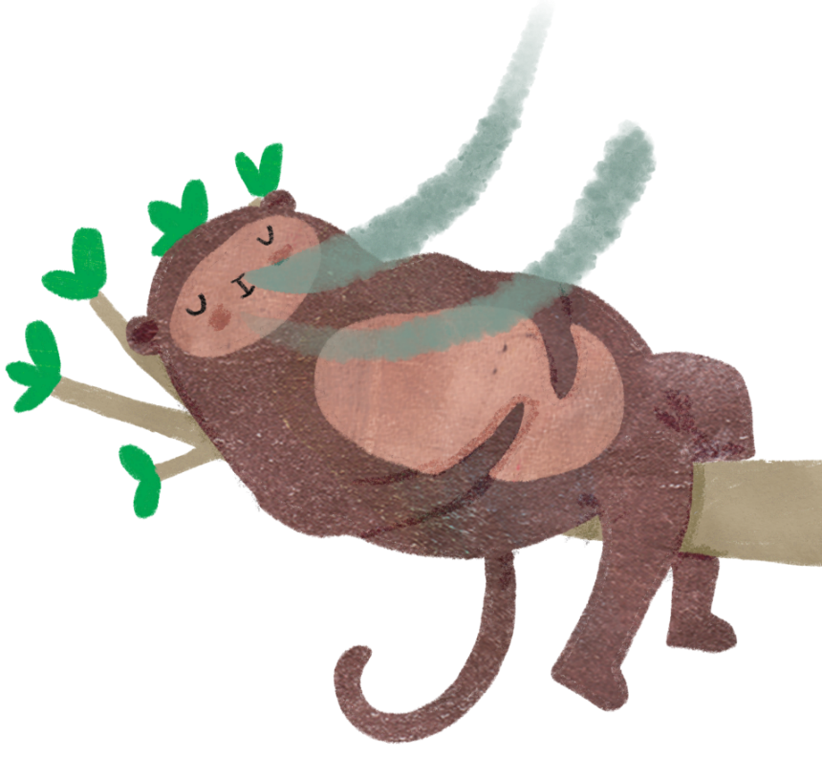

Prepared by:
Your name here
Your business name here if you have one
your website link if you have one
your logo if you have one

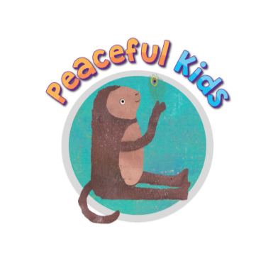

Table of Contents

Executive Summary 3
Background 4
Impact of COVID-19 4
Introduction to Mindfulness 5
Research on Mindfulness 6
Mindfulness Program for Schools 7
Peaceful Classrooms ‘Chill out’ 10-week Mindfulness Program 9
Peaceful Kids Intervention 8-Week Program 11
Pricing 12
About (your business or personal name here) 13
References 14

Executive Summary

Mindfulness has great potential as a key strategy for positively impacting on the learning and wellbeing outcomes of children and young people in education settings. Research has shown that the mental health and wellbeing outcomes for younger people are consistent with those observed for adults. In particular, reduction in stress, and anxiety symptoms, and increases in calmness, self-esteem, self-acceptance, self-regulation and sleep quality have been regularly observed.

Data from the Australian National Mental Health Survey shows that young people have the highest incidence and prevalence of mental illness across the lifespan, with almost one in seven 4-17 year-olds assessed as having mental disorders in the previous 12 months. Furthermore, COVID-19 has brought about a complex array of factors such as uncertainty, social isolation, and parental angst that have an impact on the mental health of children and adolescents.

With its focus on paying attention to the present moment, Mindfulness is likely to have beneficial effects on the emotional wellbeing, mental health, ability to learn and the physical health of school students. Mindfulness training is one effective and cost-efficient way to promote healthy brain development and function, and foster stress resilience. Mindfulness can be implemented at (school or organisation name here) across a 10-week period in all grades. Details of the Peaceful Kids intervention program for small groups of children who need extra support are also included in this proposal.

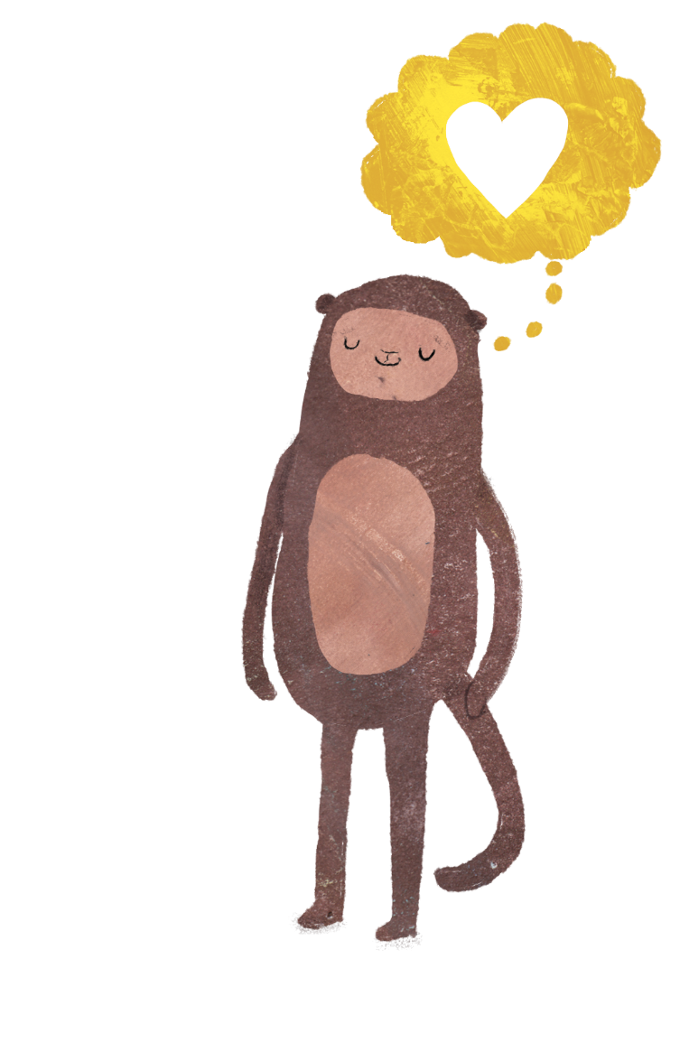
Background
Mental Illness is a major concern facing all Australians. One in five adults will experience mental illness in any one-year and one in two people in their lifetime. The World Health Organisation (WHO) predicts that depression will be the leading burden of disease by 2020. Data from the Australian National Mental Health Survey shows that young people have the highest incidence and prevalence of mental illness across the lifespan,¹ with almost one in seven 4-17 year-olds assessed as having mental disorders in the previous 12 months.² Mental health is an essential part of children’s overall health and has a complex interactive relationship with their physical health and their ability to succeed in school, at work and in society. As such the emotional wellbeing of children is just as important as their physical health. Good mental health allows children and young people to develop the resilience to cope with whatever life throws at them and grow into well-rounded, healthy adults.

Impact of COVID-19
COVID-19 has brought about a complex array of factors such as uncertainty, social isolation, and parental angst that have an impact on the mental health of children and adolescents. Predictability which is a major stabilising force for children and adolescents, has been disrupted since the COVID-19 outbreak. Children have many worries such as whether they will see their friends and extended family, go to school, or get sick. I have experienced this firsthand in my own household with my 12-year-old son and 9-year-old daughter. We as parents are usually adept at making plans for children, however, our future plans are also on hold.
Children have many worries related to the consequences of COVID-19 such as whether they will see their friends and relatives, go to school, or get sick. It is often difficult for parents to calm their children’s anxieties because of the uncertainty in their lives. Parents are typically adept at making plans for their children, but future plans are currently on hold. The challenges facing parents may interfere with their usual ability to address their children’s emotional needs.
Whilst COVID-19 is sparing most kids’ bodies, it’s not being so kind to their minds. Living in a universe that is already out of their control, they can become especially shaken when the verities they count on to give the world order-the rituals in their lives, the very day-to-day ways of living get blown to bits.
An online survey administered to children and adolescents aged 7 to 18 years during the spread of COVID-19 in China found that higher than previously reported scores of youth depression, anxiety; youth who had a family member or friend with COVID-19 had higher levels of anxiety than those who did not.
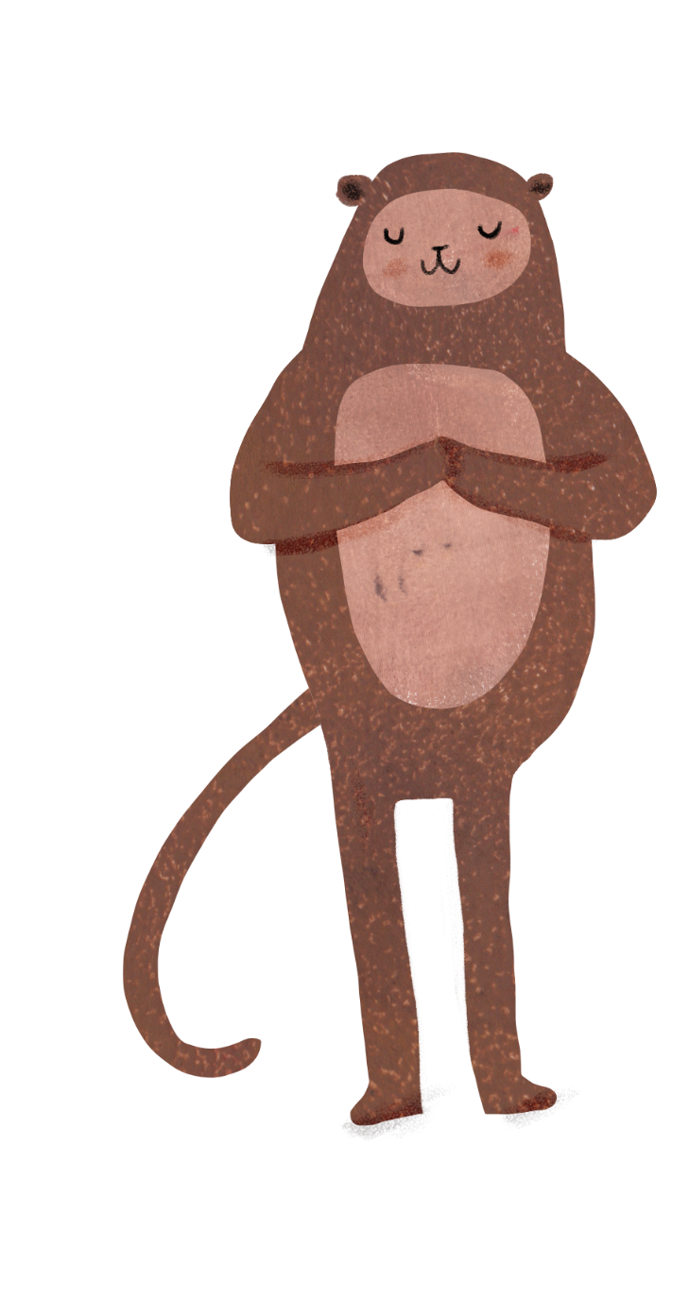
The emotional impact of the COVID-19 quarantine was also assessed for children and adolescents from Italy and Spain. Participants parents of children aged 3 to 18 years who completed a survey about the effects of the quarantine on their children, compared to before the home confinement period. The study found 85.7% of parents reported changes in their children’s emotions and behaviours during the quarantine.
The most frequently observed changes were difficulty concentrating (76.6%), boredom (52%), irritability (39%), restlessness (38.8%), nervousness (38%), loneliness (31.3%), uneasiness (30.4%), and worries (30.1%). About 75% of parents reported feeling stressed about the quarantine situation. Parental stress was associated with increased reports of emotional and behavioural symptoms in their children.³ According to a report by Australian Human Rights Commission and Kids Helpline surveyed children and young people spoke about worry, stress, feeling tapped, frustration, anger, sadness, loss and grief.⁴

Introduction to Mindfulness
Jon Kabat-Zinn (2003) describes Mindfulness as a way of ‘paying attention in a particular way; on purpose, in the present moment, and non-judgementally’. Mindfulness can be explained by giving movement to moment awareness of one’s experience without judgment. Mindfulness is not about trying to relax or to achieve a particular outcome through the process. It is the ability to be fully present without being ‘caught up’ in our thoughts. Children of all ages can benefit from Mindfulness, the simple practice of bringing a gentle accepting attitude to the present moment.
For children, Mindfulness is an excellent way to provide experiences that enhance their emotional intelligence including:
- Self-regulation
- Impulse control
- Understanding their emotions
- Controlling their emotions
- Building awareness of themselves as a whole person

The benefits of regular Mindfulness include:
- Keeping calm
- Reducing stress
- Being less reactive
- More resilience to life’s inevitable difficulties
- Increased focused and attention & ability to learn
- Increased concentration and memory
- A decrease in anxiety
- Decrease in worrying thoughts
- A renewed energy
- Reservoir of strength and resilience
- Improved sleep
- Allows compassion & empathy to grow

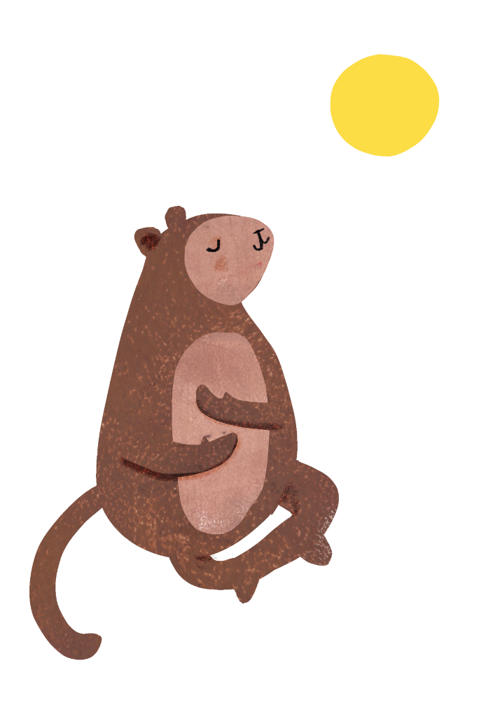
Research on Mindfulness
There have been thousands of research papers written on the benefits of Mindfulness and its health benefits over the last 40 years. It has been proved that even just a few minutes of Mindfulness a day has enormous benefits and helps children to focus and bring full attention to their tasks. To date, the majority of research into the effects of Mindfulness on children and adolescents has been carried out in the United States and, to a lesser degree, in the United Kingdom, although at least one study has also been conducted among primary school children in Australia.
This research has shown that the mental health and wellbeing outcomes for younger people are consistent with those observed for adults. Reduction in stress, and depressive and anxiety symptoms, and increases in calmness, self-esteem, self-acceptance, self-regulation and sleep quality have been regularly observed. In the Australian study, there was found to be a significant reduction in depressive symptoms and the number of children falling into the borderline or diagnostic category of the Strengths and Difficulties Questionnaire (SDQ) following completion of a 10-week Mindfulness in schools programme. Other benefits of Mindfulness training among children and adolescents include improved social and emotional competence, and behavioural regulation.
Research also suggests that Mindfulness practice also has more direct benefits on academic achievement, including an increased ability to transfer previously learned material to new situations, increased creativity, an improved ability to retain instructional knowledge, an improved ability for selective attention, and a decrease in levels of test anxiety.
Lastly, teachers also benefit from Mindfulness training. There is a wealth of research regarding the effects of Mindfulness on adults, which includes stress reduction and positive affect. This can have a great flow-on benefits for students by strengthening positive teacher-student relationships.

Mindfulness Program for Schools
By teaching Mindfulness to kids and teens, we can provide them with the tools they need to build confidence, cope with stress, and relate to uncomfortable or challenging moments.
At (your business name or personal name) we facilitate the Peaceful Kids Mindfulness and Positive Psychology program developed by Wellbeing for Kids. The Peaceful Kids program aims to lessen anxiety and stress and increase resilience in children from Prep to Year 12.
This program helps children to build their emotional resilience and equip them to deal with the day to day stresses that life brings them. Peaceful Kids is based on evidence-based therapy and research from the Mindfulness Based Stress Reduction Program (MBSR), Mindfulness-integrated Cognitive Behaviour Therapy (MiBCT), Positive Psychology and Acceptance and Commitment Therapy.
The Peaceful Kids program is endorsed by ‘Beyond Blue – Be You’ as a recognised evidence-based program for schools.
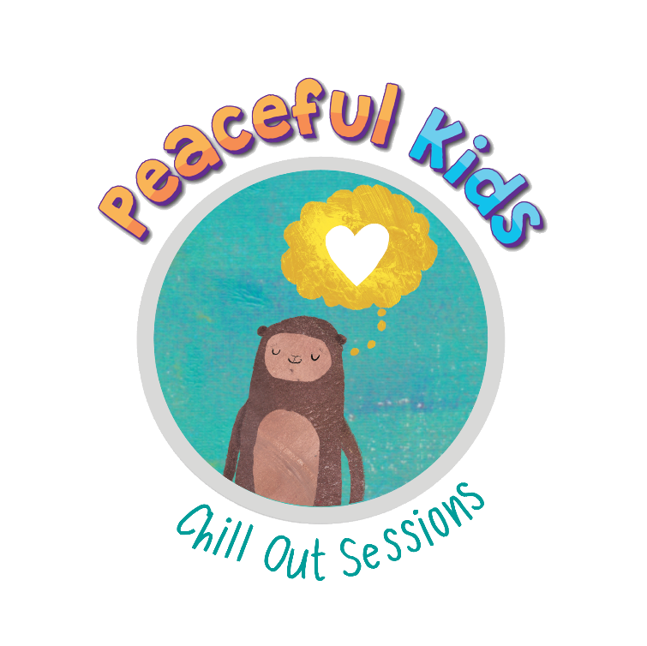

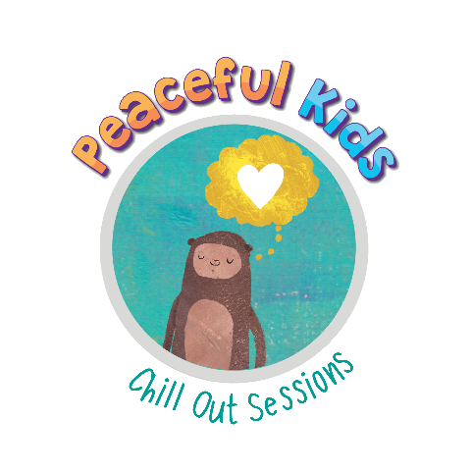
10-week ‘Peaceful Classrooms’ Mindfulness Program

– ‘Chill Out’ sessions

The 10-week Chill out Mindfulness sessions brings weekly 45-minute lessons into the classroom. Children learn essential Mindfulness skills to reduce stress, improve attention and improve emotional intelligence. Every session includes a Mindful Movement and ends with a guided Mindfulness practice.
Week 1 | Introduction to Mindfulness  - What is Mindfulness  - The core skills of Mindfulness  - Introduction to Mindfulness through a simple breathing exercise
Week 2 | How does Mindfulness help our brain?  - How Mindfulness helps the brain and affects are overall wellbeing  - Age appropriate explanation of brain anatomy to understand the stress response and areas of the brain that are impacted by Mindfulness  - Making a brain activity  - Reading the book, “Your Fantastic Plastic Brain”
Week 3 | Plant metaphor – healthy minds, healthy bodies  - Explaining connection between care for the plant and care for our brain, mental health, and our bodies  - Children plant seedlings and look after the plant for the next 7 weeks
Week 4 | Being present  - Explaining mind wandering & managing thoughts  - Reading the book, “What Does It Mean To Be Present”  - Understanding formal and informal Mindfulness

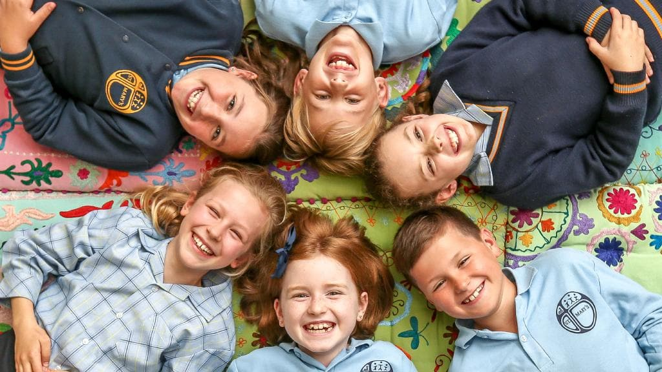
Week 5 | Training our attention  - Understanding one of the core skills of Mindfulness – self-regulation of attention.  - Understanding the wandering mind and re-directing focus  - Practice makes us better and how we practice  - Reading books, “Puppy Mind” and “Handful of Quiet”
Week 6 | How does our mind and body feel when we are stressed or calm?  - Understanding physical symptoms of stress and anxiety  - Noticing when we feel calm  - Identifying their own stress sensations  - Learning connection between Mindfulness and feeling calm
Week 7 | Noticing thoughts and feelings  - Learning to notice and understand our thoughts and feelings  - Glitter jar activity – Metaphor for noticing thoughts and feelings  - Reading the book, “Moody Cow Meditates”
Week 8 | Mindfulness of our bodies and emotions  - Learning about the ‘Mindful pause’ to manage emotions  - Recognising emotions and learning acceptance  - Reading books, “Peaceful Piggy” and “My Magic Breath”
Week 9 | Mindful Belly Breathing  - Role of breath in helping us calm down  - Using a stone on the belly to master breathing of managing our emotions and creating a sense of calm
Week 10 | Gratitude  - Understanding how gratitude helps us tune into more positive feelings  - 3 great things activity  - Developing a gratitude practice

Peaceful Kids - 8-week Intervention Program

Regularly practicing Mindfulness exercises have been shown to significantly reduce the symptoms of anxiety. A mindful approach to anxiety and stress symptoms includes emotional regulation strategies, relaxation techniques and Mindfulness strategies. During the 8-week program we work with children in groups of 4-6 who are feeling anxious, stressed or who are poor in resilience, in 60-minute lessons. Every session includes a Mindful Movement and ends with a guided Mindfulness practice. Note: Programs for 5 and 6-year-olds are modified to run over 5 weeks instead of 8.

Week 1 | Introduction to Mindfulness  Using the breath to calm the body and mind
Week 2 | Worry & Mindfulness  - Explaining worrying and normalising anxiety like other emotions  - How Mindfulness can help to lessen worrying
Week 3 | The body, brain and worrying  - Body sensations, howe worrying affects our bodies  - Body scan Mindfulness practice
Week 4 | Journaling, worry time and worry spot  - Using journaling to express feelings and cope  - Worry spot Mindfulness practice
Week 5 | Practical & expressive coping strategies  - Effective problem-solving methods for anxiety  - Tense and relax Mindfulness practice
Week 6 | Noticing thoughts and positive thoughts  - Noticing unhelpful thoughts and getting to know self-talk  - Leaves on a stream Mindfulness practice
Week 7 | 3 great things, peace, and coping cards  - Being in the flow activities  - Mindfulness of feeling practice
Week 8 | Warm & Fuzzy Book, Peaceful Kids Box & Meditation Bracelet  - Activating positive memories  - Sharing of strategies learnt

Cost
Please see below pricing for the recommended programs.
Option 1: Schools cover the cost of the programs. We provide all the learning materials at no extra cost to the school or parents.
Option 2: Parents cover the cost for their child to attend the Peaceful Kids Intervention program.
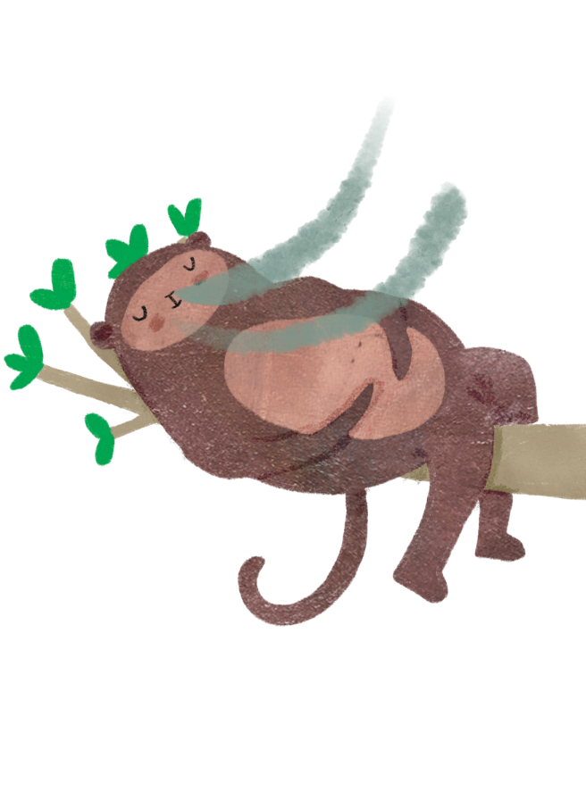
Program | Group size | Cost
Peaceful Classrooms - ‘Chill Out’ sessions  10-week Mindfulness Program during class time | Up to 26 children in a classroom setting | $3 per child per session  - School covers cost
Peaceful Classrooms - ‘Chill Out’ sessions  10-week Mindfulness Program for after school | Min 4, Max 12 | $20 per child, per session – Parents or schools cover cost
‘Peaceful Kids’  8 Week Intervention program for children who need additional support | Min 4, Max 6 | $340 per child for the 8-week program  – Parents cover cost or school supplement

Peaceful Kids program forward

by Dr. Craig Hassed
The modern world seems to be literally and metaphorically 'driving us to distraction' more than at any other time in history. This is contributed to by its faster pace, the overuse of technology and the unquestioning adoption of multitasking. Among other problems, poor attention is associated with impaired learning, memory, emotional development and empathy. Amidst this are also rising rates of poor mental health, stress, poor self-esteem and ADHD among children and adolescents. To prevent and manage problems such as these we need to address the root causes of the problem. This is where Mindfulness comes in. There is an enormous need for children to develop the skills they will need to cope with the modern world including learning to manage attention and developing skills in stress management, compassion and resilience.
There is a rapidly growing research-base on the positive role of Mindfulness for healthy childhood development and learning. Georgina Manning's 'Peaceful Kids' program makes a great contribution to helping children to develop these skills early in life - a skill that will stand them in good stead for the rest of their lives. It is practical, systematic and can help children to understand themselves better and to develop ways to not just to survive in the modern world but to thrive in it. It is also likely that the adults who learn and teach the program will derive as much from it as the children who experience it which is an added bonus. Let's face it, if adults are not teaching children to be mindful then we are teaching them to be unmindful.

Dr Craig Hassed MBBS, FRACGP
Senior Lecturer
Monash University, Department of General Practice
Coordinator of Mindfulness programs at Monash University
Founding president of the Australian Teachers of Meditation Association

About (you or your business name here)
A bit about you and or your business here

References
- Milnes, A., Pegrum, K., Nebe, B., Topfer, A., Gaal, L., Zhang, J., & Hunter, N. (2011). Young Australians: Their Health and Wellbeing 2011. Canberra: Australian Institute of Health and Welfare
- Lawrence, D., Johnson, S., Hakefost, J., Boterhoven De Haan, K., Sawyer, M., Ainley, J., Zubrick, S. (2015). The Mental Health of Children and Adolescents: Report On the Second Australian Child and Adolescent Survey of Mental Health and Wellbeing. Department of Health, Canberra
- Wagner K.D., (2020), New Findings About Children’s Mental Health During COVID-19, Retrieved from https://www.psychiatrictimes.com/view/new-findings-children-mental-health-covid-19
- Australian Human Rights Commission, (2020), Impacts of COVID-19 on Children and Young People Who Contact Kids Helpline

