Peaceful Parents
Program Proposal
(School / Organisation Name here)

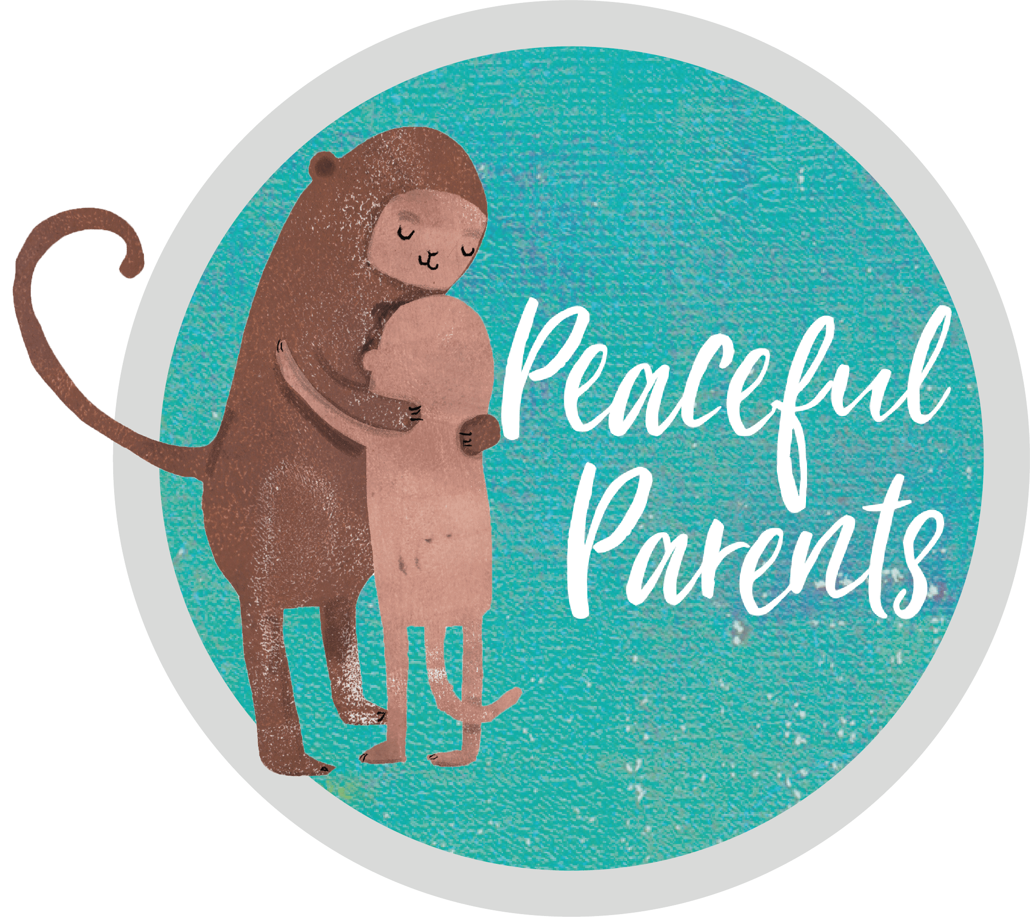

Prepared by:
Your name here
Your business name here if you have one
your website link if you have one
your logo if you have one

Table of Contents

Executive Summary 3
Background 4
Impact of COVID-19 5
Introduction to Mindfulness 6
Research on Mindfulness 7
Peaceful Parents Program 8
Peaceful Parents Program Overview 9
Pricing 10
About (your business or personal name here) 11
References 12

Executive Summary

Mindfulness has great potential as a key strategy for positively impacting on the learning and wellbeing outcomes of children and young people in education settings. Research has shown that the mental health and wellbeing outcomes for younger people are consistent with those observed for adults. In particular, reduction in stress, and anxiety symptoms, and increases in calmness, self-esteem, self-acceptance, self-regulation and sleep quality have been regularly observed.

Data from the Australian National Mental Health Survey shows that young people have the highest incidence and prevalence of mental illness across the lifespan, with almost one in seven 4-17 year-olds assessed as having mental disorders in the previous 12 months. Furthermore, COVID-19 has brought about a complex array of factors such as uncertainty, social isolation, and parental angst that have an impact on the mental health of children and adolescents.

With its focus on paying attention to the present moment, Mindfulness is likely to have beneficial effects on the emotional wellbeing, mental health, ability to learn and the physical health of school students. Mindfulness training for both adults and children is one effective and cost-efficient way to promote healthy brain development and function, and foster stress resilience.

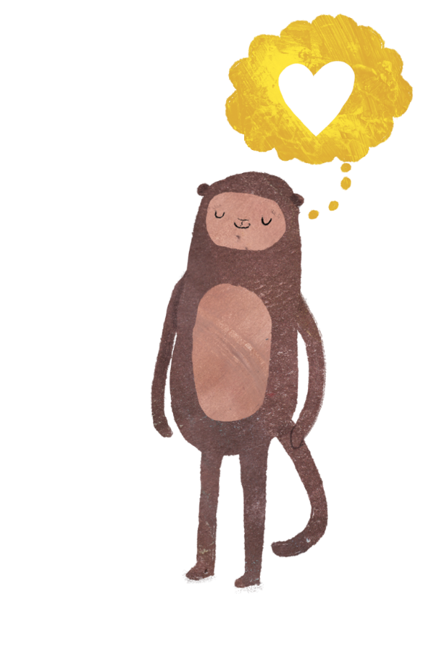
Background
Mental Illness is a major concern facing all Australians. One in five adults will experience mental illness in any one-year and one in two people in their lifetime. The World Health Organisation (WHO) predicts that depression will be the leading burden of disease by 2020. Data from the Australian National Mental Health Survey shows that young people have the highest incidence and prevalence of mental illness across the lifespan,¹ with almost one in seven 4-17 year-olds assessed as having mental disorders in the previous 12 months.² Mental health is an essential part of children’s overall health and has a complex interactive relationship with their physical health and their ability to succeed in school, at work and in society. As such the emotional wellbeing of children is just as important as their physical health. Good mental health allows children and young people to develop the resilience to cope with whatever life throws at them and grow into well-rounded, healthy adults.
Parent wellbeing is also vital. Research shows that just by parents practising Mindfulness, that their children will benefit significantly. ³ If parents are well supported to be Mindful in their personal lives as well as mindfully connecting to their children, everyone will benefit. In such a distracted and frantic world that we live in, it is now more important than ever that parents are given the skills to lessen their own stress as well as supporting the wellbeing of their children.

“Mindfulness is more than just a “buzzword.” It’s about being present and giving each task your full attention. Taking the time to listen and understand your child’s problems, promotes trust and emotional connection leading to a richer and more authentic relationship.”
Lea Waters, Melbourne University

Impact of COVID-19
COVID-19 has brought about a complex array of factors such as uncertainty, social isolation, and parental angst that have an impact on the mental health of children and adolescents. Predictability which is a major stabilising force for children and adolescents, has been disrupted since the COVID-19 outbreak. Children have many worries such as whether they will see their friends and extended family, go to school, or get sick. I have experienced this firsthand in my own household with my 12-year-old son and 9-year-old daughter. We as parents are usually adept at making plans for children, however, our future plans are also on hold.
Children have many worries related to the consequences of COVID-19 such as whether they will see their friends and relatives, go to school, or get sick. It is often difficult for parents to calm their children’s anxieties because of the uncertainty in their lives. Parents are typically adept at making plans for their children, but future plans are currently on hold. The challenges facing parents may interfere with their usual ability to address their children’s emotional needs.
Whilst COVID-19 is sparing most kids’ bodies, it’s not being so kind to their minds. Living in a universe that is already out of their control, they can become especially shaken when the verities they count on to give the world order-the rituals in their lives, the very day-to-day ways of living get blown to bits.
An online survey administered to children and adolescents aged 7 to 18 years during the spread of COVID-19 in China found that higher than previously reported scores of youth depression, anxiety; youth who had a family member or friend with COVID-19 had higher levels of anxiety than those who did not.
The emotional impact of the COVID-19 quarantine was also assessed for children and adolescents from Italy and Spain. Participants parents of children aged 3 to 18 years who completed a survey about the effects of the quarantine on their children, compared to before the home confinement period. The study found 85.7% of parents reported changes in their children’s emotions and behaviours during the quarantine.
The most frequently observed changes were difficulty concentrating (76.6%), boredom (52%), irritability (39%), restlessness (38.8%), nervousness (38%), loneliness (31.3%), uneasiness (30.4%), and worries (30.1%). About 75% of parents reported feeling stressed about the quarantine situation. Parental stress was associated with increased reports of emotional and behavioural symptoms in their children.⁴ According to a report by Australian Human Rights Commission and Kids Helpline surveyed children and young people spoke about worry, stress, feeling tapped, frustration, anger, sadness, loss and grief.⁵
Introduction to Mindfulness
Jon Kabat-Zinn (2003) describes Mindfulness as a way of ‘paying attention in a particular way; on purpose, in the present moment, and non-judgementally’. Mindfulness can be explained by giving movement to moment awareness of one’s experience without judgment. Mindfulness is not about trying to relax or to achieve a particular outcome through the process. It is the ability to be fully present without being ‘caught up’ in our thoughts. Children of all ages can benefit from Mindfulness, the simple practice of bringing a gentle accepting attitude to the present moment.
For children, Mindfulness is an excellent way to provide experiences that enhance their emotional intelligence including:
- Self-regulation
- Impulse control
- Understanding their emotions
- Controlling their emotions
- Building awareness of themselves as a whole person

The benefits of regular Mindfulness include:
- Keeping calm
- Reducing stress
- Being less reactive
- More resilience to life’s inevitable difficulties
- Increased focused and attention & ability to learn
- Increased concentration and memory
- A decrease in anxiety
- Decrease in worrying thoughts
- A renewed energy
- Reservoir of strength and resilience
- Improved sleep
- Allows compassion & empathy to grow

During the Peaceful Parents program, parents learn how to practice Mindfulness for themselves as well as supporting their children in Mindfulness skills. Parents also learn Mindful Parenting strategies that impact positively on their children’s wellbeing.

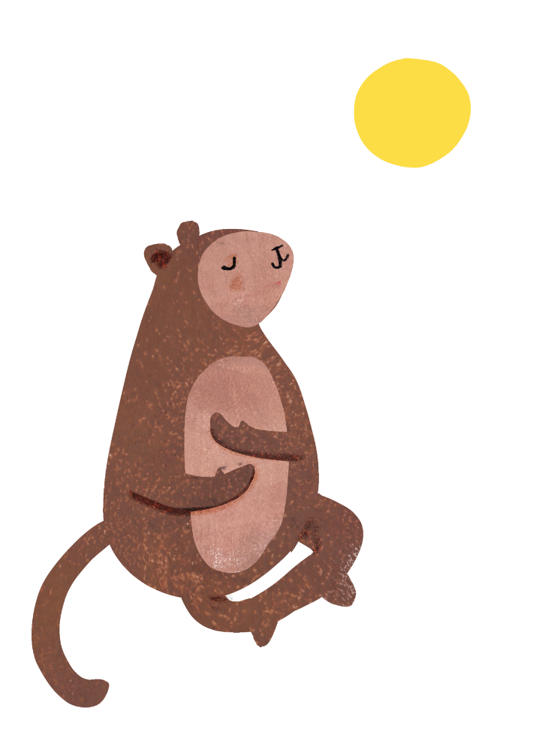
Research on Mindfulness
There have been thousands of research papers written on the benefits of Mindfulness and its health benefits over the last 40 years. It has been proved that even just a few minutes of Mindfulness a day has enormous benefits and helps children to focus and bring full attention to their tasks. To date, the majority of research into the effects of Mindfulness on children and adolescents has been carried out in the United States and, to a lesser degree, in the United Kingdom, although at least one study has also been conducted among primary school children in Australia.
This research has shown that the mental health and wellbeing outcomes for younger people are consistent with those observed for adults. Reduction in stress, and depressive and anxiety symptoms, and increases in calmness, self-esteem, self-acceptance, self-regulation and sleep quality have been regularly observed. In the Australian study, there was found to be a significant reduction in depressive symptoms and the number of children falling into the borderline or diagnostic category of the Strengths and Difficulties Questionnaire (SDQ) following completion of a 10-week Mindfulness in schools programme. Other benefits of Mindfulness training among children and adolescents include improved social and emotional competence, and behavioural regulation.
Research also suggests that Mindfulness practice also has more direct benefits on academic achievement, including an increased ability to transfer previously learned material to new situations, increased creativity, an improved ability to retain instructional knowledge, an improved ability for selective attention, and a decrease in levels of test anxiety.
Lastly, parents also benefit from Mindfulness training. There is a wealth of research regarding the effects of Mindfulness on adults, which includes stress reduction and positive affect. This has a great flow-on benefits for their children.

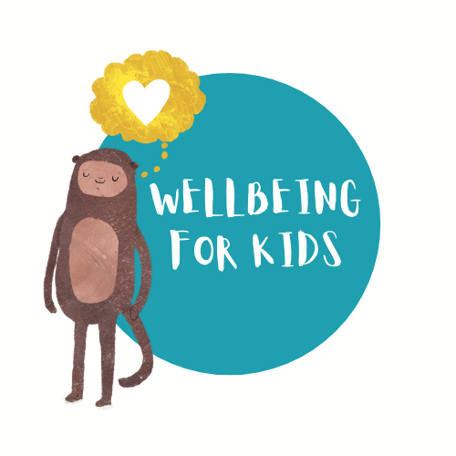
Peaceful Parents Program for Schools
Peaceful Parents is a Mindfulness and Positive Psychology based parenting program to increase resilience in both parents and their children. At (your business name or personal name) we facilitate the Peaceful Parents Mindfulness and Positive Psychology program developed by Wellbeing for Kids.
‘Peaceful Parents’ is a strength-based parenting 4 session workshop that is engaging, practical and supportive for parents. Parents learn strategies to lessen stress, enjoy parenting more as well as learning practical strategies to build resilience in their children.

The purpose of the Peaceful Parents program is to enhance parent wellbeing which in turn positively impacts on their children’s wellbeing. Not only is there growing evidence that reducing stress levels in parents naturally lessens the stress in the household for other family members, but it is also common sense. Professor Lea Waters from Melbourne University has found in her research that “Mindfulness in parenting significantly reduces children’s stress levels”. Also as Thich Nhat Han states "In a family, if there is one person who practices mindfulness, the entire family will become more mindful." In his many years of teaching mindfulness to families, he believes that mindfulness has a ripple effect in families.
‘The strongest predictor of life success for children is being able to regulate emotions. This means when they are feeling anxious or avoidant that they can bring themselves back to being resilient. We can teach children these skills. Even better we can show them how to do it. This is where the ‘Peaceful Parents’ program is so powerful. By focusing on listening, communication, and mindful parenting we can demonstrate these skills to our children day in day out.’
Andrew Fuller
Psychologist, Family Therapist & Author

Peaceful Parents Overview
Peaceful Parents is a 4 session Mindfulness, Positive Psychology & Mindful Educational program for any parent or carer. The Peaceful Parents program covers a range of strategies and concepts and life skills that are based around Mindfulness and Positive Psychology. Over 4 weeks parents learn:

Parents discover strategies for themselves...
- Formal & Informal Mindfulness strategies
- Slowing life down & being more in Flow
- Enjoying parenting more & reducing stress
- Resilience building exercises & strategies
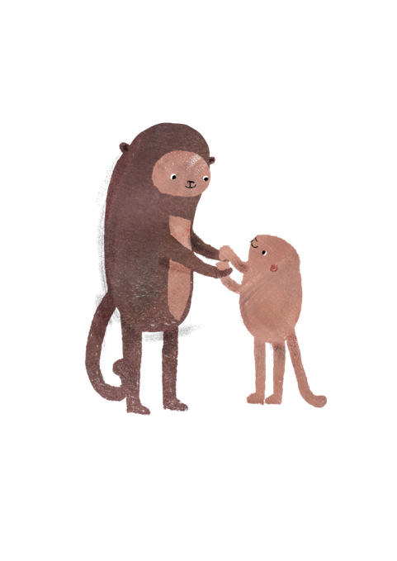
- Mindful parenting strategies
- Self-Care & Wellbeing Boosters
- Positive psychology strategies to boost wellbeing
- Resilience building strategies

And to support their children...
- Mindful listening & responding
- Effective Coping Strategies
- Managing children’s feelings & worries
- Problem Solving strategies

Peaceful Parents 4 Week Workshop Overview

Week 1 | Week 2
- Introduction to workshop  - Guidelines for the group  - Introduction to Mindfulness  - Reflective listening skills | - Mindfulness & Stress  - Informal Mindfulness  - Doing Mode / Being Mode  - Feelings – name it & tame it
Week 3 | Week 4
- Coping Strategies  - Journaling  - Problem Solving using the 4C’s  - Self-Care | - Positive Thinking  - Gratitude  - Mindful Play  - Flow  - Wellbeing Boosters

Cost
Please see below pricing for the recommended programs.
Option 1: Schools cover the cost of the program. We provide all the learning materials at no extra cost to the school or parents.
Option 2: Parents cover the cost to attend the program.

Program | Group size | Cost
‘Peaceful Parents  4 Week Mindfulness & Positive Psychology program for Parents / Carers | 8 to 12 parents | $200 per parent/family  Parents cover cost or schools cover cost or part supplement cost

Peaceful Parents program forward

by Andrew Fuller

“The strongest predictor of life success for children is being able to regulate emotions. This means when they are feeling anxious or avoidant that they can bring themselves back to being resilient. We can teach children these skills. Even better we can show them how to do it.

This is where the ‘Peaceful Parents’ program is so powerful. By focusing on listening, communication and mindful parenting we can demonstrate these skills to our children day in day out. We also know that our relationships thrive when we Connect, Protect and Respect one another (CPR). Peaceful Parents builds this by helping parents:

Connect
- To their strengths as parents
- Identifying strengths of children
- Developing cultures of unconditional positive regard

Protect
- Know how to handle strong emotions
- How to listen well
- Calming mindfulness and emotional regulation

Respect
- Using the 4 C’s – calm, curious, coach and communicate to develop ways to peacefully parent children

Georgina and the team at Wellbeing for Kids should be congratulated for putting together such a useful resource for parents. Bravo!! “

Andrew Fuller
Author, Clinical Psychologist and Family Therapist
Hon. Fellow, Uni of Melbourne
Ambassador of Adolescent Success
Ambassador of ALDAF
Ambassador for Mind Matters

About (you or your business name here)
A bit about you and or your business here

References
- Milnes, A., Pegrum, K., Nebe, B., Topfer, A., Gaal, L., Zhang, J., & Hunter, N. (2011). Young Australians: Their Health and Wellbeing 2011. Canberra: Australian Institute of Health and Welfare
- Lawrence, D., Johnson, S., Hakefost, J., Boterhoven De Haan, K., Sawyer, M., Ainley, J., Zubrick, S. (2015). The Mental Health of Children and Adolescents: Report On the Second Australian Child and Adolescent Survey of Mental Health and Wellbeing. Department of Health, Canberra
- Waters, L. (2016) The Relationship between Child Stress, Child Mindfulness and Parent Mindfulness. University of Melbourne.
- Wagner K.D., (2020), New Findings About Children’s Mental Health During COVID-19, Retrieved from https://www.psychiatrictimes.com/view/new-findings-children-mental-health-covid-19
- Australian Human Rights Commission, (2020), Impacts of COVID-19 on Children and Young People Who Contact Kids Helpline

