Peaceful Teens Proposal
(The School / Organisation Name here)

Prepared by:
Your name here
Your business name here if you have one
your website link if you have one
your logo if you have one

Table of Contents

Executive Summary 3
Background 4
Impact of COVID-19 4
Introduction to Mindfulness 5
Research on Mindfulness 6
Mindfulness Program for Schools 7
Peaceful Teens Intervention 8-Week Program 11
Pricing 12
About (your business or personal name here) 13
References 14

Executive Summary

Mindfulness has great potential as a key strategy for positively impacting on the learning and wellbeing outcomes of teenagers and young people in education settings. Research has shown that the mental health and wellbeing outcomes for younger people are consistent with those observed for adults. In particular, reduction in stress, and anxiety symptoms, and increases in calmness, self-esteem, self-acceptance, self-regulation and sleep quality have been regularly observed.

Data from the Australian National Mental Health Survey shows that young people have the highest incidence and prevalence of mental illness across the lifespan, with almost one in seven 4-17 year-olds assessed as having mental disorders in the previous 12 months. Furthermore, COVID-19 has brought about a complex array of factors such as uncertainty, social isolation, and parental angst that have an impact on the mental health of teenagers and adolescents.

With its focus on paying attention to the present moment, Mindfulness is likely to have beneficial effects on the emotional wellbeing, mental health, ability to learn and the physical health of school students. Mindfulness training is one effective and cost-efficient way to promote healthy brain development and function, and foster stress resilience. Mindfulness can be implemented at (school or organisation name here) across a 10-week period in all grades. Details of the Peaceful Teens intervention program for small groups of teenagers who need extra support are also included in this proposal.

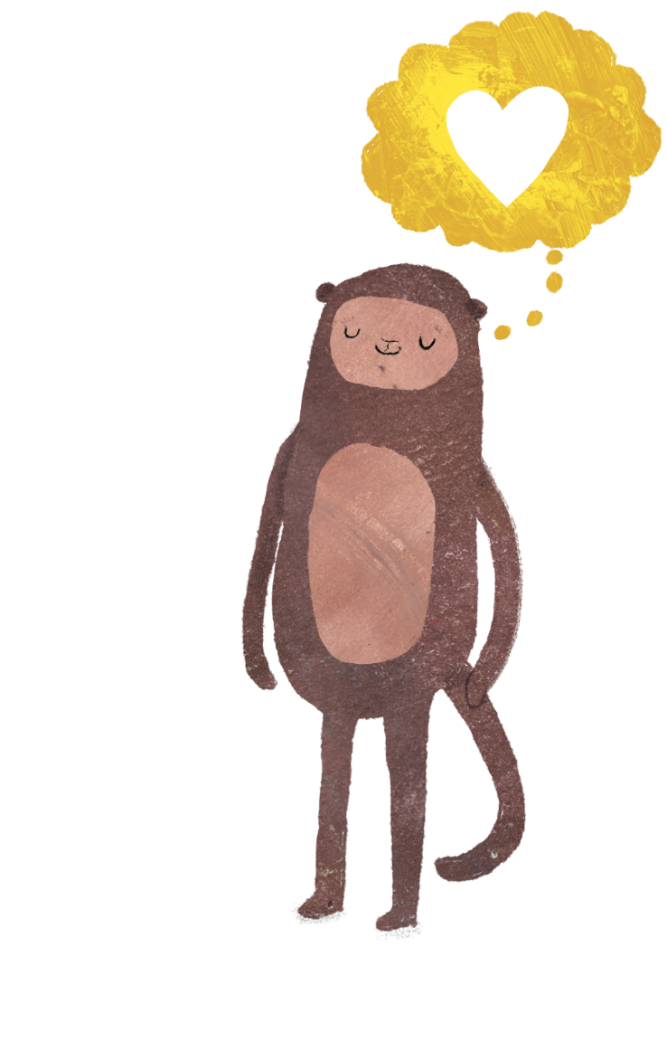
Background
Mental Illness is a major concern facing all Australians. One in five adults will experience mental illness in any one-year and one in two people in their lifetime. The World Health Organisation (WHO) predicts that depression will be the leading burden of disease by 2020. Data from the Australian National Mental Health Survey shows that young people have the highest incidence and prevalence of mental illness across the lifespan,¹ with almost one in seven 4-17 year-olds assessed as having mental disorders in the previous 12 months.² Mental health is an essential part of teenagers’s overall health and has a complex interactive relationship with their physical health and their ability to succeed in school, at work and in society. As such the emotional wellbeing of teenagers is just as important as their physical health. Good mental health allows teenagers and young people to develop the resilience to cope with whatever life throws at them and grow into well-rounded, healthy adults.

Impact of COVID-19
COVID-19 has brought about a complex array of factors such as uncertainty, social isolation, and parental angst that have an impact on the mental health of teenagers and adolescents. Predictability which is a major stabilising force for teenagers and adolescents, has been disrupted since the COVID-19 outbreak. Teenagers have many worries such as whether they will see their friends and extended family, go to school, or get sick. I have experienced this firsthand in my own household with my 12-year-old son and 9-year-old daughter. We as parents are usually adept at making plans for teenagers, however, our future plans are also on hold.
Teenagers have many worries related to the consequences of COVID-19 such as whether they will see their friends and relatives, go to school, or get sick. It is often difficult for parents to calm their teenagers’s anxieties because of the uncertainty in their lives. Parents are typically adept at making plans for their teenagers, but future plans are currently on hold. The challenges facing parents may interfere with their usual ability to address their teenagers’s emotional needs.
Whilst COVID-19 is sparing most Teens’ bodies, it’s not being so kind to their minds. Living in a universe that is already out of their control, they can become especially shaken when the verities they count on to give the world order-the rituals in their lives, the very day-to-day ways of living get blown to bits.
An online survey administered to teenagers and adolescents aged 7 to 18 years during the spread of COVID-19 in China found that higher than previously reported scores of youth depression, anxiety; youth who had a family member or friend with COVID-19 had higher levels of anxiety than those who did not.
The emotional impact of the COVID-19 quarantine was also assessed for teenagers and adolescents from Italy and Spain. Participants parents of teenagers aged 3 to 18 years who completed a survey about the effects of the quarantine on their teenagers, compared to before the home confinement period. The study found 85.7% of parents reported changes in their teenagers’s emotions and behaviours during the quarantine.
The most frequently observed changes were difficulty concentrating (76.6%), boredom (52%), irritability (39%), restlessness (38.8%), nervousness (38%), loneliness (31.3%), uneasiness (30.4%), and worries (30.1%). About 75% of parents reported feeling stressed about the quarantine situation. Parental stress was associated with increased reports of emotional and behavioural symptoms in their teenagers.³ According to a report by Australian Human Rights Commission and Teens Helpline surveyed teenagers and young people spoke about worry, stress, feeling tapped, frustration, anger, sadness, loss and grief.⁴

Introduction to Mindfulness
Jon Kabat-Zinn (2003) describes Mindfulness as a way of ‘paying attention in a particular way; on purpose, in the present moment, and non-judgementally’. Mindfulness can be explained by giving movement to moment awareness of one’s experience without judgment. Mindfulness is not about trying to relax or to achieve a particular outcome through the process. It is the ability to be fully present without being ‘caught up’ in our thoughts. Teenagers of all ages can benefit from Mindfulness, the simple practice of bringing a gentle accepting attitude to the present moment.
For teenagers, Mindfulness is an excellent way to provide experiences that enhance their emotional intelligence including:
- Self-regulation
- Impulse control
- Understanding their emotions
- Controlling their emotions
- Building awareness of themselves as a whole person

The benefits of regular Mindfulness include:
- Keeping calm
- Reducing stress
- Being less reactive
- More resilience to life’s inevitable difficulties
- Increased focused and attention & ability to learn
- Increased concentration and memory
- A decrease in anxiety
- Decrease in worrying thoughts
- A renewed energy
- Reservoir of strength and resilience
- Improved sleep
- Allows compassion & empathy to grow

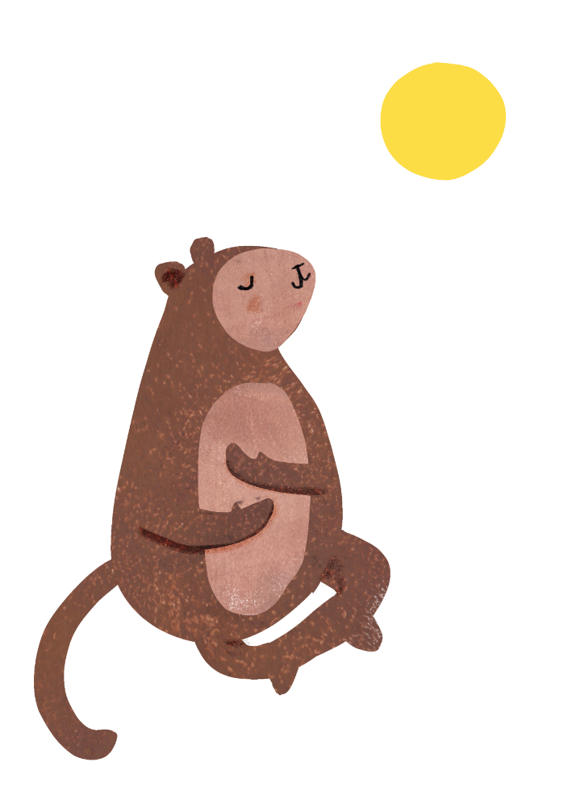
Research on Mindfulness
There have been thousands of research papers written on the benefits of Mindfulness and its health benefits over the last 40 years. It has been proved that even just a few minutes of Mindfulness a day has enormous benefits and helps teenagers to focus and bring full attention to their tasks. To date, the majority of research into the effects of Mindfulness on teenagers and adolescents has been carried out in the United States and, to a lesser degree, in the United Kingdom, although at least one study has also been conducted among primary school teenagers in Australia.
This research has shown that the mental health and wellbeing outcomes for younger people are consistent with those observed for adults. Reduction in stress, and depressive and anxiety symptoms, and increases in calmness, self-esteem, self-acceptance, self-regulation and sleep quality have been regularly observed. In the Australian study, there was found to be a significant reduction in depressive symptoms and the number of teenagers falling into the borderline or diagnostic category of the Strengths and Difficulties Questionnaire (SDQ) following completion of a 10-week Mindfulness in schools programme. Other benefits of Mindfulness training among teenagers and adolescents include improved social and emotional competence, and behavioural regulation.
Research also suggests that Mindfulness practice also has more direct benefits on academic achievement, including an increased ability to transfer previously learned material to new situations, increased creativity, an improved ability to retain instructional knowledge, an improved ability for selective attention, and a decrease in levels of test anxiety.
Lastly, teachers also benefit from Mindfulness training. There is a wealth of research regarding the effects of Mindfulness on adults, which includes stress reduction and positive affect. This can have a great flow-on benefits for students by strengthening positive teacher-student relationships.

Peaceful Teens - 8-week Intervention Program

Regularly practicing Mindfulness exercises have been shown to significantly reduce the symptoms of anxiety. A mindful approach to anxiety and stress symptoms includes emotional regulation strategies, relaxation techniques and Mindfulness strategies. During the 8-week program we work with teenagers in groups of 4-6 who are feeling anxious, stressed or who are poor in resilience, in 60-minute lessons.
Week 1 | Introduction to program & Mindfulness  - Introduction to Mindfulness  - Training the ‘Monkey Mind’  - Normalising anxiety & worry feelings
Week 2 | Worry & Mindfulness  - Things that ‘stress me out’ (identifying worries & stressors)  - Plant metaphor – prevention with Mindfulness  - Mindful Belly Breathing & the Brain  - Neuroscience of Mindfulness
Week 3 | Body, Brain & Worrying  - Body Sensations  - Understanding the Stress Response  - Understanding & Making a brain
Week 4 | Journaling Feelings / Worries & Problem Solving  - Journaling to express feelings and worries  - Using problem solving framework  - Controlling the ‘controllables’  - Support seeking
Week 5 | Coping Strategies & Self Care  - Coping strategies for stress & worry  - Self-Care Strategies  - Window of tolerance  - Maladaptive & Adaptive strategies
Week 6 | Noticing Thoughts & Positive Self Talk  - Positive thought cards / affirmations  - Leaves on a stream activity (thought defusion)  - Negativity Bias – Safety Seeking  - Noting and labelling thoughts strategy
Week 7 | Managing Big Feelings  - Managing strong feelings with Mindfulness  - Body sensations & Feelings  - Self-Validation of feelings & acceptance of feelings
Week 8 | Flow, Gratitude & Positive Traits  - Gratitude Journal  - Being in Flow / Informal Mindfulness  - Positive traits

Cost
Please see below pricing for the recommended programs.
Option 1: Schools cover the cost of the programs. We provide all the learning materials at no extra cost to the school or parents.
Option 2: Parents cover the cost for their child to attend the Peaceful Teens Intervention program.
Program | Group size | Cost
‘Peaceful Teens’  8 Week Intervention program for teenagers who need additional support | Min 4, Max 6 | $340 per teenager for the 8-week program  – Parents cover cost or school supplement

Peaceful Kids program forward

by Dr. Craig Hassed
The modern world seems to be literally and metaphorically 'driving us to distraction' more than at any other time in history. This is contributed to by its faster pace, the overuse of technology and the unquestioning adoption of multitasking. Among other problems, poor attention is associated with impaired learning, memory, emotional development and empathy. Amidst this are also rising rates of poor mental health, stress, poor self-esteem and ADHD among teenagers and adolescents. To prevent and manage problems such as these we need to address the root causes of the problem. This is where Mindfulness comes in. There is an enormous need for teenagers to develop the skills they will need to cope with the modern world including learning to manage attention and developing skills in stress management, compassion and resilience.
There is a rapidly growing research-base on the positive role of Mindfulness for healthy childhood development and learning. Georgina Manning's 'Peaceful Teens' program makes a great contribution to helping teenagers to develop these skills early in life - a skill that will stand them in good stead for the rest of their lives. It is practical, systematic and can help teenagers to understand themselves better and to develop ways to not just to survive in the modern world but to thrive in it. It is also likely that the adults who learn and teach the program will derive as much from it as the teenagers who experience it which is an added bonus. Let's face it, if adults are not teaching teenagers to be mindful then we are teaching them to be unmindful.

Dr Craig Hassed MBBS, FRACGP
Senior Lecturer
Monash University, Department of General Practice
Coordinator of Mindfulness programs at Monash University
Founding president of the Australian Teachers of Meditation Association

About (you or your business name here)
A bit about you and or your business here

References
- Milnes, A., Pegrum, K., Nebe, B., Topfer, A., Gaal, L., Zhang, J., & Hunter, N. (2011). Young Australians: Their Health and Wellbeing 2011. Canberra: Australian Institute of Health and Welfare
- Lawrence, D., Johnson, S., Hakefost, J., Boterhoven De Haan, K., Sawyer, M., Ainley, J., Zubrick, S. (2015). The Mental Health of Teenagers and Adolescents: Report On the Second Australian Child and Adolescent Survey of Mental Health and Wellbeing. Department of Health, Canberra
- Wagner K.D., (2020), New Findings About Teenagers’s Mental Health During COVID-19, Retrieved from https://www.psychiatrictimes.com/view/new-findings-teenagers-mental-health-covid-19
- Australian Human Rights Commission, (2020), Impacts of COVID-19 on Teenagers and Young People Who Contact Teens Helpline

