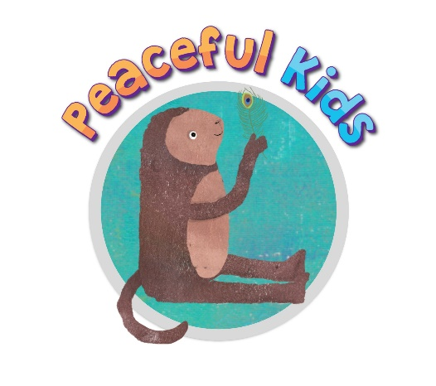
Peaceful Kids Permission -Participation via live video call
I give permission for my child to participate in the Peaceful Kids educational program via (ZOOM, Google Hangouts – edit).
I understand the program will be run by (your name) and that my child will be meeting each week for 8 weeks with other students.
The first session will be commencing in Week … (week beginning DATE/TIME).

Terms and Conditions
- As this program will be adapted for online learning due to the Coronavirus, some activities and resources will be adapted to suit the online space.
- Resources may be emailed to you prior to the sessions. Please do not share these with anyone outside of your home. Resources are not usually emailed due to copyright reasons however due to these circumstances; we ask you to help keep the resources within the copyright restrictions.
- Due to child safety reasons, it is required that a parent be present in the same room as their child. Parent’s do not have to participate in the session however it is important that a parent is in the same room as the child. For younger children, parents are encouraged to join in on the session.
- Children need to be in a living room space and not in their bedrooms.
- Due to parents being present for this adapted online program, it is very important that parents keep anything shared by the students or parents as confidential.
- Sessions are not be recorded by the Facilitator or participants.
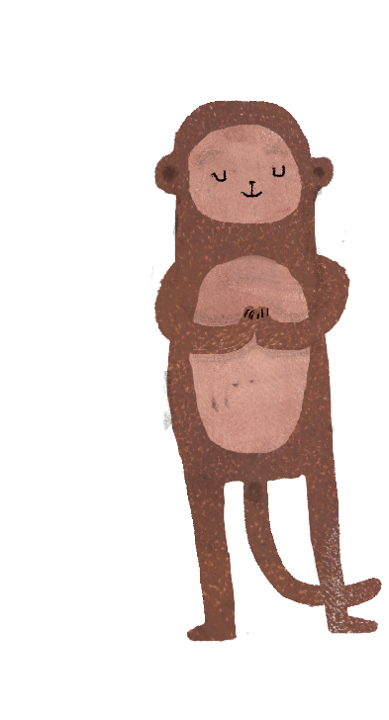
- Occasionally children are not suitable for this group workshop which can be due to several reasons including the group dynamics. If your child is struggling to manage the group environment with other children, you will be contacted to discuss alternative options for your child. Alternative options for children can include offering individual sessions or being included in another group at another time. If your child is not being respectful to other children or very disruptive, all efforts will be made to keep your child in the group, however at times children may be asked to leave the group and this will be discussed with you to manage the best way forward.
- Full payment is required before the 8-week Peaceful Kids program for your child to participate in the program.

I agree with the above Terms and Conditions
Child’s Name:
Parent’s Name:
Parent Signature:
Date:

